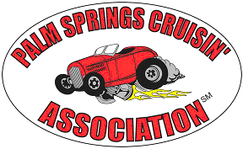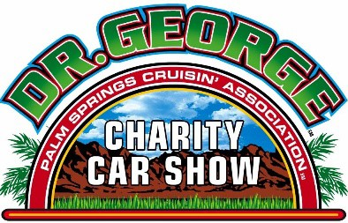
74801 Hovley Lane E. #14063 ∙ Palm Desert, CA 92255 ∙
www.palmspringscruisinassociation.com
Volunteering and participating is an integral part of being a member of the Palm Springs Cruisin’ Association. We need our members to volunteer for our Cruise-Ins and the Dr. George Charity Car Show, and to participate in Club Activities.

PSCA 2024/2025 MEMBERSHIP FORM
(PLEASE PRINT CLEARLY)
Date:

Name:

Primary e-mail:

Spouse or Significant Other:

Street address:

City: State: Zip:

Phone:

Vehicle(s) (year, make, model):

(use reverse side of application for additional vehicles)

Please check NO □ if you DO NOT want your information on the roster and available to other PSCA members.

Membership: $50. NOTE: If not renewed by October Cruise-In: membership will be terminated.
PSCA Cruise In Windshield Tag – pick up at PSCA Monthly Meeting or Cruise-In… good from Oct-May season. .
Monthly Cruise In at The River – Windshield TAG = free entry for 1 car during 2024-2025 season – May to-Sept closed
Memberships completed by 31 Aug 2024 will have the windshield tag mailed to them.

Total: $________ Cash: $______ Check: $______ #______ PSCA Initials______

RELEASE OF LIABILITY: In consideration of the acceptance of the right to participate, all volunteers, participants, spectators and Palm Springs Cruisin’ Association℠ members, by execution or receipt of this form, release and discharge The Palm Springs Cruisin' Association and its officers, directors, agents, assigns, representatives, volunteers and servants, and anyone else connected with the management or presentation of P.S.C.A. Cruise In, Dr. George Charity Car Show, or any other Palm Springs Cruisin' Association club activities of and from any and all known or unknown damages, injuries, losses, judgments, and/or claims from any cause whatsoever that may be suffered by entrant to his person or property. Further, each participant expressly agrees to indemnify all of the foregoing entities, firms, persons and bodies of and from any and all liability occasioned or resulting from the conduct of all participants. All participants agree that any controversy, claim or dispute arising out of the participation in the activity identified above and/or the foregoing Release of Liability shall be determined through arbitration administered by the American Arbitration Association.

Signature Date

